**NEUROID NETWORK GENOME - FRONT END**

**Introduction**

We are looking forward to develop a user interface which takes the inputs for the neuroid network and represents the output from the backend code which will be connecting to the front-end interface.

We’ve used HTML programming language to build the web user interface we did use local server host for the representation.

Our HTML code is consisting of various input terms and also a file uploader segment which is used for the training and testing datasets.

Our future Enhancements will be looking into connecting multiple user interfaces using various web programming languages.

**Front end Display:**

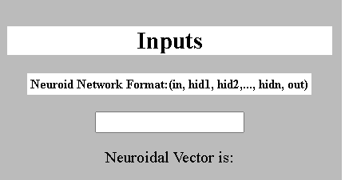

This particular segment takes values such as 2, 3, ….,2 as neuroid vector and passes them to the backend code.

Where 2+3+2=7 will be total number of nodes in a neuroid network.

This will be passed to the network configuration team.

<form>

<div class="input">

<label for="vector">Neuroid Network Format:(in, hid1, hid2, ..., hidn, out)</label><br><br>

<input type="text" id="vector" name="vector" required><br>

<p>Neuroidal Vector is: <span id="vec"></span></p>

</div>

<br>

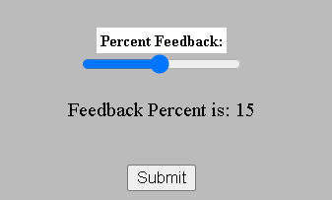

Feed back ratio for the propagation of the neuroid network will be given as the input in the user interface. Even this parameter is passed to the network configuration team.

<div class="slider1">

<label for="feedback">Percent Feedback:</label><br>

<input type="range" min="1" max="30" value="15" class="slider1" id="feedback" required><br>

<p>Feedback Percent is: <span id="demo"></span></p>

<br>

</div>

<input type="submit" id="submit" name="Submit" value="Submit" onclick="getInputValue();"><br><br>

<script>

var vector_input = document.getElementById("vector");

var vector_output = document.getElementById("vec");

vector_output.innerHTML = vector_input.value;

vector_input.oninput = function() {

vector_output.innerHTML = this.value;

}

</script>

<script>

var slider1 = document.getElementById("feedback");

var output1 = document.getElementById("demo");

output1.innerHTML = slider1.value;

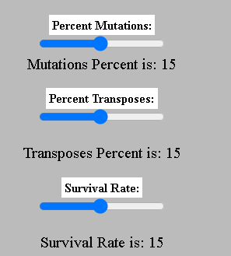

These parameters are required for the genetic calculations for the neuroid network these values are sent to genetic algorithm team code in the back end.

<div class="slider2">

<label for="mutations">Percent Mutations:</label><br>

<input type="range" min="1" max="30" value="15" class="slider2" id="mutations" required><br

<p>Mutations Percent is: <span id="permuta"></span></p>

</div>

<div class="slider3">

<label for="transposes">Percent Transposes:</label><br>

<input type="range" min="1" max="30" value="15" class="slider3" id="transposes"><br>

<p>Transposes Percent is: <span id="pertran"></span></p>

</div>

<div class="slider4">

<label for="survival"> Survival Rate:</label><br>

<input type="range" min="1" max="30" value="15" class="slider4" id="survival">

<p>Survival Rate is: <span id="survrate"></span></p>

</div>

<br>

<script>

var slider2 = document.getElementById("mutations");

var output2 = document.getElementById("permuta");

output2.innerHTML = slider2.value;

slider2.oninput = function() {

output2.innerHTML = this.value;

}

</script>

<script>

var slider3 = document.getElementById("transposes");

var output3 = document.getElementById("pertran");

output3.innerHTML = slider3.value;

slider3.oninput = function() {

output3.innerHTML = this.value;

}

</script>

<script>

var slider4 = document.getElementById("survival");

var output4 = document.getElementById("survrate");

output4.innerHTML = slider4.value;

slider4.oninput = function() {

output4.innerHTML = this.value;

}

</script>

</form>

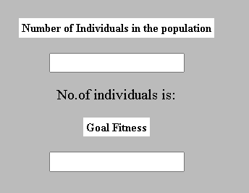

Here the population and goal fitness values are sent to the genetic algorithm code where the number of populations is generated and the goal fitness is a percentage between 0-100% where the particular generation reaches maximum goal of the fitness ratio. Where fitness starts from low and ends with highest value w.r.t to generation.

<form>

<div class="numpop">

<label for="numpop">Number of Individuals in the population</label><br><br>

<input type="Number" id="numpop" name="numpop" required><br>

<p>No.of individuals is:<span id="pop"></span></p>

</div>

<div class="fit">

<label for="fit">Maximum Fitness</label><br><br>

<input type="Number" id="fit" name="fit" required><br><br>

<p>Maximum Fitness is:<span id="maxfit"></span></p>

<script>

var numpop_input = document.getElementById("numpop");

var numpop_output = document.getElementById("pop");

numpop_output.innerHTML = numpop_input.value;

numpop_input.oninput = function() {

numpop_output.innerHTML = this.value;

}

</script>

<script>

var fit_input = document.getElementById("fit");

var fit_output = document.getElementById("maxfit");

fit_output.innerHTML = fit_input.value;

fit_input.oninput = function() {

fit_output.innerHTML = this.value;

}

</script>

</form>

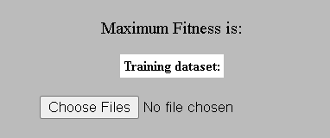

This column represents the file upload activity where the file consists of training and testing datasets provided by dataset team.

<div class="column1" style="background-color:white;">

<center>

<h2>Outputs</h2>

<form>

<label for="">Initiate Training</label>

<button onclick="myFunction()">Run</button>



<script>

function myFunction() {

window.open("output.html");

}

</script>

<button onclick="pauseVid()" type="button">Pause</button>

<button onclick="pauseVid()" type="button">stop</button><br>

</form>

</center>

</div>

**Structure Code:**

<!DOCTYPE html>

<html>

<head>

<title>Neuroid Network Genome</title>

<meta name="viewport" content="width=device-width, initial-scale=1">

<style>

* {

box-sizing: border-box;

}

/* Create two equal columns that floats next to each other */

.column {

float: left;

width: 23%;

padding: 10px;

height: 1000px; /* Should be removed. Only for demonstration */

}

.column1 {a

float: right;

width: 60%;

padding: 10px;

height: 1000px; /* Should be removed. Only for demonstration */

}

/* Clear floats after the columns */

.row:after {

content: "";

display: table;

clear: both;

}

label {

background-color: white;

color: black;

font-weight: bold;

padding: 3px;

font-size: small;

}

</style>

</head>

<body style="background-color:white">

<center>

<h1 style="background-color:rgba(245, 39, 85, 0.29);">Neuroid Network Genome</style></h1>

</center>

<div class="column" style="background-color:#bbb;">

<center>

<h2 style="background-color:white;">Inputs</h2>

<style="background-color:rgba(245, 39, 85, 0.29);">

</body>

</style>

</center>

</html>